REGIONAL ALLIANCE FOR RURAL HEALTH
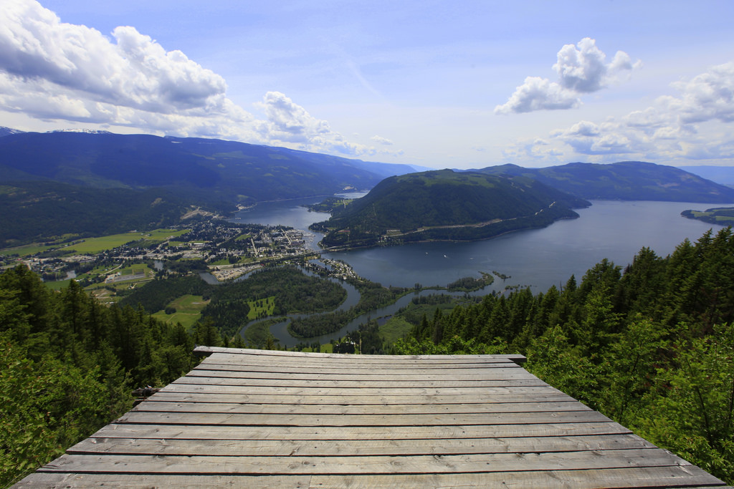

May 7, 2018 |  | Community engagement event: North Okanagan

Regional Alliance for Rural Health
C O M M U N I T Y E N G A G E M E N T E V E N T: NORTH OKANAGAN

BACKGROUND: REGIONAL ALLIANCE FOR RURAL HEALTH
The Regional Alliance for Rural Health (RARH) formed in fall 2016 with 11 partners collaborating to align and articulate a vision to increase and advance knowledge to improve rural health and wellbeing, though collaborative community-engaged action research on the social determinants of health. A memorandum of understanding was developed and approved in 2017. Excerpts include:

- We are committed to working collaboratively to improve rural health and wellbeing for all individuals within Interior Region.
- We will establish a regional alliance for applied research and academic health and wellness research that engages rural communities of the Interior region.
- We support community engaged practice, research and policy development.

The next phase of RARH development is critical to meet the MOU mission. Part of that phase includes community engagement. It is important to engage rural communities via citizens and community partner organizations to further develop and contribute to the Alliance goals on an on-going basis. Sustainable engagement with rural community representatives (citizens and community partners) from across the region to enable:

- Co-creation of a balanced Alliance with equal representation of current core partners and rural community representatives.
- Regular opportunities to communicate requests/recommendations for rural health evidence and research in balance with those coming from academia.
- Regular opportunities to participate on research teams as equal partners
- On-going support to build capacity and enable effective, mutually beneficial partnerships (e.g. training, funding, mentorship).

The overall goal is on-going, regular engagement – in multiple forms - with rural community representatives; to first identify and co-create the system and then to participate in regular, sustainable and balanced research partnerships with academic and health professionals. Events are the first opportunity to co-create the means to develop sustained relationships between rural citizen/community partners and the

Alliance. The purpose of the partnerships are to enable critical rural citizen ‘voice’ to identify rural community health research and evidence needs and to invite rural citizen/community partners to participate on future research teams to co-create knowledge.

The following questions were discussed at a RARH steering committee meeting: What is the optimal engagement, for the Alliance at this phase of development, to partner with citizens and community partners? How might we balance Alliance membership and sustain partnerships with rural citizen and community partners to inform and contribute to community-engaged rural health research in the Interior? The steering committee agreed it was important to host a series of community engagement events in 4-5 sub-regions of the Interior, during April-May 2018, to announce the Alliance, and engage rural community participation.

“What is Rural? Degrees of Rural – Salmon Arm is urban to Sicamous, & Sicamous is urban to Malakaw…CONTEXT is key”

ALLIANCE COMMUNITY ENGAGEMENT EVENTS SPRING 2018
On May 7, 2018, the RARH hosted a community engagement event in Sicamous, British Columbia, and funded by the University of BC Community Engagement Partnership Recognition Fund. Participants were from a variety of community services agencies including, not-for-profits, social, and health agencies (see Appendix A). The event was to begin the conversation about community-engaged research and to identify community gaps and needs in the current services.

The information gathered and present here within, was from notes and observations taken by facilitators during the event, and reflects the perspectives of participants who live and work in rural communities in the North Okanagan area. These participants are critically important for ensuring rural communities have a voice for the overall health and wellbeing of those communities.

The intent of the community event was to engage community members in meaningful, authentic connections. Working together to identify and meet community needs. The goal was to secure collaboration and active community involvement in beginning to define a research agenda that would work to create sustainable health and social services in rural settings.

“When unincorporated, a lack of understanding of needs and services – getting missed”

The agenda for the day (see appendix B) included the opportunities for the research facilitators to understand the rural context. Facilitators and participants explored what the social determinants of Health (SDoH) looked like and how these were experienced in rural communities. Although many identified SDoH were viewed both as strengths and challenges, some that resonated with the participants included:

- People in rural communities have a hard time accessing health services, further away from hospitals which decrease their health outcomes
- Housing
    - Less rigid code
    - Rental standards different
    - Older housing stock
    - Tourists and seniors moving in causing availability ↓ price ↑
    - Many vacant most of year due to vacation homes (46%)
    - People are moving even more rural in order to afford a home
- Economic challenges
    - Lack of diversity mostly tourism
    - Mills closing
    - Being unincorporated
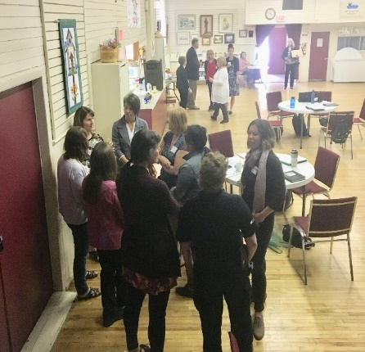
    - Regional District-getting missed
    - Cost living challenges
- Food security
    - Rural benefit is less fast foods
    - Only one grocery store
    - Local food sources
    - Community garden free to use
    - Tourism season increases the costs of foods
- Lack of transportation
    - Causing isolation
    - Access issues
    - Bus system built on volunteers
    - No real safe walkways
    - Encouraged to build corridors ie. Walking trails & use of rail trail
- Youth
    - Excellent pre-schools
    - High school lacks choice, limited activities
    - Lack of youth resources – youth centre/recreation
    - Parkview elementary most improved school in BC
    - Sicamous council planning a ski/toboggan hill
- Health Services lacking
    - Nurse practitioner Sorrento
    - Sicamous Doctor retiring
    - Rural Shuswap Health Services Network a positive
    - Access major challenge
    - Fewer resources especially for aging population
- Changing demographics
    - More seniors (56%)
    - Young people leaving and not coming back
- Relying on volunteers
    - Older volunteers
    - Capacity dwindling
- Supportive and connectedness within communities

“How do we pull together for collaborative solutions?”

One of the important activities completed was an in-depth discussion on important issues, gaps, or needs where the participants shared their perspectives. Participants worked through the barriers/challenges, factors that influence or contribute to health and wellbeing, and the areas they see need to be addressed.

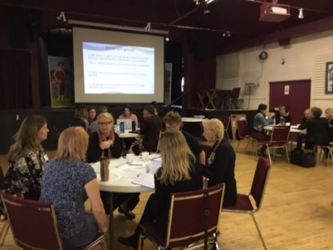
To get a sense of real rural issues – what is your community grappling with?

- Transportation
  - Limited times & days
  - no taxi service
  - Eagle Valley Trans. Is volunteer run
  - School bus not accessible for all who live rural
  - Increases social isolation
- Affordable housing for working people not recreational users
- Supports for families
  - No licensed child care
  - Aging in place is needed
- Food security – affordability and accessibility
- Access to services (doctors & other health/social services)
  - seasonal pressures
  - limited hours
- Aging infrastructures – volunteer pool is shrinking
- Mental health and addictions
- Lack of recreational facilities – no access to school gyms and limited hours
- Communities (Enderby, Sicamous, Malakwa) being lumped together, context-specific service gaps. What is needed in specific communities
- Communications – lack of internet/fibre optic

“Same small number of volunteers who do it all”

What are the possibilities for research to help address these problems?
  - Try to create and inform opportunities
  - Work with communities and identify need – what will galvanize the people, stakeholders?
  - Explore ways to bring together several/many health care services – one-stop shop
- What types of services are most needed to inform the development of a Health & Wellness Centre?
  - How can solutions from research on other communities be effective for our community?
    - Identify what is working already, look elsewhere, try to replicate and/or adapt
    - Upstream ideas/solution, ie. School bus for multi-purposes, hotel pool for community use

  - Transportation sustainability
    - Keep track of needs/use
    - 60-70% have to go out-of-town for health care service
    - Look for creative and cost-effective solutions ie. Multi-purpose school bus
  - Look at researching on Aging-in-Place in rural context
  - Ensure issues and solutions are community-specific instead of being lumped in with communities like Salmon Arm to make more relevant
  - Demonstrate relevance – show the cost of the impact/effect if NOT addressed
  - Education – lack of choice and access
  - Need for economic stimulus
    - Rail Trail promote this
    - Promote lifestyle
    - Develop our own identity (separate from Salmon Arm)
    - Determine what industries are looking for & encourage the move to rural

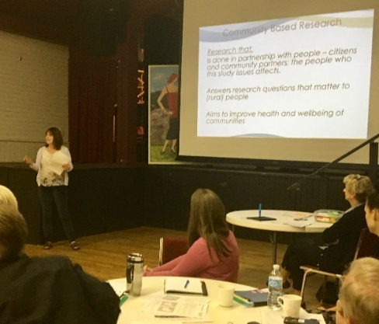

“Want to connect with the Alliance to share the vision from our Community”

In a “world café”, participants provided ideas and suggestions to inform the Regional Alliance for Rural Health how to reach and engage communities and individuals. As a new network, it was important to understand how RARH can make important connections with rural communities; seeking input was a valuable undertaking as a number of factors, suggestions, and action items offered were:
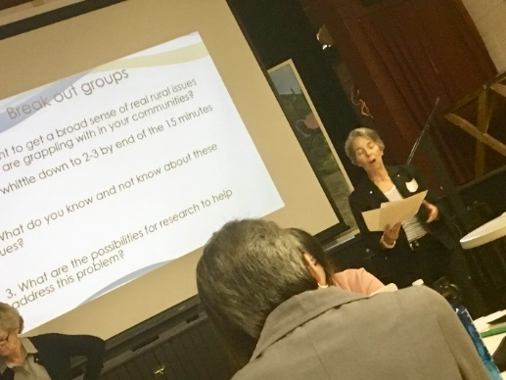
In an ideal world, what role would the Alliance offer to
support your research and information needs?

- Create understanding of what RARH does – webinar introducing the Alliance
- Capacity to help do the work – ie. needs assessments, facilitation, community development, grant writing
- Connect researchers with community partners for collaborations
  - Keep people in the loop of what needs and projects there might be
  - Helping communities to be ready
- Help communities define questions and develop solutions
- Having all my community partners ready and willing to be on board – everyone willing to take a role
- Partnerships, capacity building, and sustainability with initiatives
- Time given for staff to be involved
- Provide sustainability; ensure that outcomes will continue.
  - Help re-establish closer connection to IH to get things done
- Provide a website for:
  - Database current research
  - Past rural BC research- as this enables communities to use solutions/implementations that have worked in other communities. (on a provincial scale rather than just the Interior)
  - to ensure research isn’t repeated or mistakes made/avoid re-inventing the wheel
  - provide access to research projects – disseminate
  - information sharing across communities
  - training
- Provide the partners and participants with a defined ‘Roles and Responsibilities’
  - The roles of partners and of members of the Alliance
  - Communication link
- Provide direction, offer face-to-face meetings,
- Funding to have community partners involved in research projects and Alliance
- A listening ear

What role would you like to see the Alliance play at a Provincial level?

- To be an provincial advisor on rural issues
  - resources
  - funding
  - database
  - help set priorities
  - taking the voice of rural communities to government
- Advocacy – be a voice to government (local, Interior Health, provincial)
  - Funding for action/implementation not just studies
  - Policy development – research to influence policy
  - Help them understand the barriers
  - Build capacity
  - Balance the rural with the urban lens
- Be the glue to prevent duplication
- Develop collaborative , positive relationship with the province
- Bridging the gap between provincial services & ministries
- Informing on rural health & wellness policies, services, and supports
- Strengthening voice of rural communities in BC – increase rural lobbying power

“Maintain the history of the efforts and government initiatives & promises”

What would it take, for you to commit to a partnership with the Alliance?
- Funding to attend meetings
  - Travel, child care covered
- Clearly defined roles & responsibilities, purpose, time commitment
- Commitment for shared knowledge – we are the partners with lived experiences
- Access to information for general use
- Research with a commitment to follow-up and/or implement with communities – need results
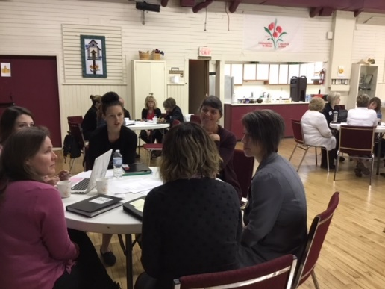
- Community readiness
  - Establish some groundwork
  - Identify community priorities
  - Ensure community capacity
  - Partnership commitment
- Sustainability & time not wasted and solution-focused
  - Continuity & transition over time
  - Continued feedback loop
  - Communicate and celebrate milestones and accomplishments
- What is the commitment? Need clear understanding and language of:

- roles, responsibilities
  - time commitments
  - what and who is involved?
  - If it can help us get where we need to go
  - What’s in it for us? Need to know this
- Face-to-face meetings, Web conferencing, video/teleconferencing, webinar training
- Passion, commitment, and leadership - community champions
- Focusses on improving rural health, communities would see results – actions on research
- Educating and getting support from decision-makers in my organization

“Promote Awareness and Education of rural contextual issues”

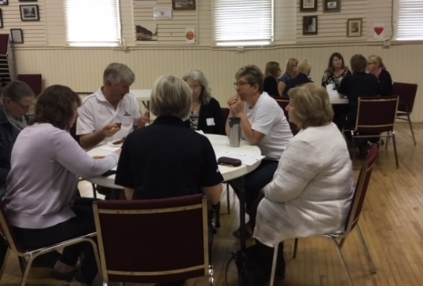

Summary
The community event provided the opportunity for networking and relationship development, as well as to introduce the Regional Alliance for Rural Health (RARH). RARH developed greater understanding of rural community concerns, challenges, and gaps in health and social service needs. Participants had the opportunity to share their ideas and identify priorities for rural community health research and evidence needs and to enable
greater understanding of rural community strengths.

Evaluation feedback highlighted overall satisfaction with event with 87% agreeing or strongly agreeing with the subject was relevant to them and their communities. Eighty percentage stated they would like to attend a more advance event on the subject. Approximately 25% of the 24 participants registered to affiliate with the Alliance in a variety of ways. See Appendix C for the RARH Registration form.

Follow-up
At the end of the event, an invitation was made to participants to express their interest and ongoing willingness to join in the RARH and to enlist as a potential community research by attending a Rural Health Research symposium. The symposium will be held on May 29th, 2018, with the goal of active community involvement and collaboration
to begin to define a research agenda that would work to create sustainable health and social services in rural settings. Participants were also invited to attend the Alliance annual meeting the day after the symposium on May 30th, both in being held in Nelson, BC.

“Nothing About Us Without Us = Success of Rural Research”

Appendices:

Attendee List

Event Outline/Agenda RARH Registration Form
IH Research Project Inventory

Attendee List

NAME | ORGANIZATION | EMAIL ADDRESS
Betty Brown | IH Community Research Lead | betty.brown@interiorhealth.ca
Tracy Christianson | Thompson Rivers University | tchristianson@tru.ca
Zoe Hawrys | Thompson Rivers University - Student Researcher | Inforarh2018@gmail.com
Andrea Burrows | IH Community Research Lead | andrea.burrows@interiorhealth.ca
Donna Helgeson | Sicamous PHN | donna.helgeson@interiorhealth.ca
Evan Parliament | CEO District of Sicamous | eparliament@sicamous.ca
Greg Kyllo rep. Holly (morning) | MLA | greg.kyllo.mla@leg.bc.ca
Gwyneth Gau | Early Childhood Development | ggau@telus.net
Jamie Sherlock | Recreation Coordinator | recreation@sicamous.ca
Anita Ely | IH Healthy Communities | Anita.ely@interiorhealth.ca
Linda Boyd | Public Health dietician | linda.boyd@interiorhealth.ca
Janelle Rimell | IH Healthy Communities Coordinator | janelle.rimell@interiorhealth.ca
Janet McClean-Senft | Eagle Valley Resource Center | edevcss@telus.net
Kathy Crandlemire | BC Ambulance Station Unit Chief | kathleen.crandlemire@bcehs.ca
Malcolm Makayev | District of Sicamous Counsellor | mmakayev@sicamous.ca
Pam Beech | Eagle Valley Resource Center | pbeech@telus.net
Sue McCrae | South Shuswap Health Services | ds.mc@telus.net
Suzie Cameron | Community Paramedic Program | susan.cameron@bcehs.ca
Laurie Chapman | MCFD Director of Operations | laurie.chapman@gov.bc.ca
Ashley Irvine | MCFD Child Protection Leader | tami.lund@gov.bc.ca
Terry Rysz | Mayor of Sicamous | trysz@sicamous.ca
Judy Gillespie | University of BC - Okanagan | Judy.gillespie@ubc.ca
Joan Bottorff | University of BC – Okanagan | Joan.bottorff@ubc.ca
Shannon Hecker | CMHA | shannon.hecker@cmha.bc.ca

Alliance Community Engagement Event outline

Time | Item
9:30 am | Doors open – coffee available Registration and informal networking Sign in, photo release
9:55 am | short video as call to order
10 am | General welcome & introduce Leona One Owl Hall  -Opening Prayer  -Overview of the day  -Introduce the Alliance  -Rapid self - intros.
10:25 am | Values exercise and ice breaker
10:40 am | HEALT H & W ellb eing  Social Determinants of Health - video Table group discussion
11:00 am | R ESEAR CH  -Why is research in rural health important?  -What can research/evidence do for me and my rural community?  -Knowledge Translation  -What is CB PAR?
11:15 | COMMUNITY PARTNERS - Role for community partners in research – levels and types of engagement, time & training commensurate with the role.  Video Testimony  Table discussion groups –discuss and reflect on all that you’ve heard.
11:50 am –  12:00 pm | RHSRNbc study overview  Building a Collaborative Research Team to address the Health and Wellbeing of Rural and Remote Communities in south central BC through consultation and engagement.
12:00- 12:45 | Lunch and mingle
12:45 | Check in and recap.
12: 55 pm | Wo rld Café style di scussi on #1  General theme: Community input for rural health research and evidence needs?
2:00 pm | Wo rld Café style di scussi on #2  General theme: Your ideas, input and suggestions to inform the Alliance.
2:40 | Report back and priority setting For both sessions
3 pm | Share future Alliance activity - Annual meeting, web portal to facilitate research etc. Explain the signup sheet & evaluations  Goodbye and safe travels

Regional Alliance for Rural Health Registration Form

